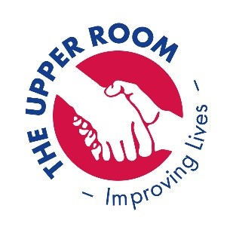
UR4Driving – Useful websites for Theory Practice.

As of Monday 23rd March 2020, the UR4Driving premises will be closed until further notice due to the government guidelines surrounding Covid-19. We appreciate that this will be difficult for some and want to do our best to ensure that we can lessen the impact of this.
We will do our best to support you continually throughout this period. You can use this time to continue with your theory and hazard perception practice. We would encourage you to practice as much as possible and send us through to the mobile pics of your results. We will have the mobile and are here to answer all questions that we can to help.
We have compiled a variety of different sites that you can use to continue your hard work, we would encourage this as much as possible. We understand for some, who are test ready this is disappointing, but for others that are perhaps not quite there yet, this is a great opportunity for you to develop your knowledge and to show you we will after demonstrating just one pass (both hazard and theory) book your test straight away.. once we are back.

https://www.driving-theory-test.com/hazard-perception
https://www.test-questions.com/
https://www.theory-test-online.co.uk/free-hazard-peception-test-demo.htm
https://www.driving-school-beckenham.co.uk/mocktheory3.html
https://toptests.co.uk/mock-theory-test/
https://www.gov.uk/theory-test/revision-and-practice
https://www.dvsalearningzone.co.uk/
https://www.drivingtestsuccess.com/product/car-theory-hazard-perception-revision-dts-anytime-online-training
https://theorypass.co.uk/- you can do different tests and it will show you and record what you have done. Useful.
Please continue to use all the resources you have. Another good way to learn if you do not have the internet is to create your own resources from your knowledge. Revision cards, games, etc. This is a good way for embedding your learning and to keep you focused and motivated during this time.
If we can help in any way, please do not hesitate to contact us via email or phone.
Ur4driving@theupperroom.org.uk

Take care and we look forward to seeing you all soon.
Elaine and Sam
UR4Driving

